Strategic People Development Consultant, Facilitator and Coach

Ilona Lott
- MAA and MBA  - Affiliate CIPD Member  - Board Member of the Estonian Association of People Management, PARE  - Certificate in Mindfulness, Coaching, Mentoring, Psychological Well-Being  - Talent Assessor from PDI Ninth House  - Cubiks Personality Assessor  - Estonian HR Hackathon Awards Judge 2019  - Student at Taltech Digital Transformation in Organisation Master of Science Programme 2020-2021  Expertise: strategical people management, culture and change management, leadership, team and individual development, digital transformation in organisations, future of work |  |  | 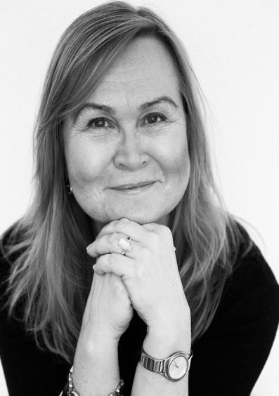
My work experience evolves over the last 25 years from the business roles in sales and organization development to people management roles in talent development, strategic human resources, people and culture change, communication etc. I have worked primarily in foreign cultures with a wide range of different nationalities, e.g. 42 different nationalities in the Gulf & Pakistan team. I am a practitioner in leadership and HR and today acting both as an internal and an external consultant. In 2016, I established my company Human Element Solutions to deliver Strategic HR, Organizational Design, Change management & Future Ways of Working, Digital Transformation Consultancy, training and coaching.
Overview | Human Element Solutions was founded a few years ago with the goal of helping business leaders to transform their organisations and help them in building agile, innovative and engaged diverse workforce.  I acted as a Partner/ Consultant in Executive Lab and spread my knowledge/ experience by creating broader scope of services e.g. David Clutterbuck masterclass “How to Lead your Team to the TOP? “, Leadership Development Programme proposals for various customers etc.  In 2016 acted as a mentor/ coach in different corporate social responsibility projects e.g. “Let’s Do it World”, “Superheroes”.  The thread in my career is people, diversity and business. Over 20years experience in Human Resources function and over fifteen years in sales, business development and general management. This vast experience and knowledge in Human Resources cover both strategy and operations with specific focus on Talent Management, Change Management, International Executive Recruitment, Leadership Development, Operational Efficiency.  Prior to setting up Human Element Solutions, I had significant internal consultancy and training experience, spending 6 years managing change& people development programmes in the Middle East, Africa, Turkey, Central Asia and the Balkans.  Vice President Human Resources & Internal Communication for Middle east & Turkey ; until 2012 also Africa & Caribbean, Schneider Electric  Member of Executive Committee of the Middle East and African Zone, Member of the Gulf Management Team  Responsibilities & Achievements:  - Managed a team of 14 people in more than 70 countries covering headcount of around 9000 people.  - Lead a Human Resources team of 12 people in Gulf (UAE/Oman/Qatar/Kuwait/Bahrain/Pakistan) by putting in place the Shared Services and Business Partner model.  - Lead a 3 year business strategy deployment plan across the Gulf (internal Program called ‘Connect’).  - Implemented new People Software: TalentLink Recruitment, TalentLink Performance, My LearningLink (e-learning), payroll, HR Metrics system etc.  - Initiated and executed Leadership Development Program ‘Saker Falcon’ for all the people managers in Gulf  (ca.85 people) to improve the engagement levels to drive for better business results.  - Reduced operational cost by 20% increasing the efficiency of HR operations: clear service level agreement, less tailor made processes, sharing resources etc.  - Worked with Human Resources and line managers on new set of incentives that improve the performance of each department and enhance employees’ motivation to achieve goals.  - Increased Employer brand awareness by aligning the internal vision to country’s vision, and by initiating programs to improve customer experience, e.g. ‘Exciting Futures in the Middle East’.  - Improved Employee Net Promoter Score by 25% within 2 years by putting in place Focus Groups and Action Plans and measuring the results on quarterly basis.  Prior to that I held a position of Human Resources Director, Tallinn Water Company, Tallinn, Estonia  Acted as a Change Leader and the Head of Human Resources in the newly privatized water company. The strategic investors being United Utilities from UK and a French Water company together with the municipality of Tallinn. I was asked to join the Executive Committee and carry out the total turnaround of the company.  - Acted as a leader in redesigning and restructuring of the company to make it profitable and efficient, changing the culture and leadership principles in the organization, downsizing around 35% of total headcount, outsourcing non-core activities, recruiting new skills/competencies focusing on service mindset, flexibility and teamwork.  - Built a 5year People Strategy based on the business plan with the engagement of employee representatives and leaders.  - Played an active role in IPO of the company.  - Created cross functional career paths inside the organization to provide development and retain talents.  - Created a new Performance and Career management system, Job Grading system, Reward system.  - Became an adviser for people related subjects in business associations and public speaker at conferences.  - Put in place Coaching and Mentoring systems created from the needs analysis of the employees.  My Personality: Inspirational - Energetic - Open & Straightforward - Convincing – Persistent – Result Driven.
Recent interventions | - Delivering leadership development programme for an equipment renting company. Introducing coaching skills, practicing feedback sessions, setting up developmental goals for behavioural change.  - Designing a culture change programme for an international company.
Areas of expertise | - Designing organisational change & behavioural change  - Facilitating change workshops  - Team development initiatives  - Organisational change – particularly culture change & embedding values  - Leadership development  - Digital Change and impact on people
Client types/ experience | CEOs, MDs, Heads of Human Resources, Heads of OD, managers in organisations
Industry  experience | Construction, Consultancy, Banking & Insurance, Wholesale & Retail, Water & Wastewater, Energy Management: Power, Energy, Infrastructure, IT and Building
Some of my clients |  | Storent, Olympic Entertainment Group, Ty Nordic etc.
Professional affiliations | - Member of the Chartered Institute of Personnel and Development, CIPD  - Member of PARE, HR Development Association  - Member of KNÜ, Career Planning Association
Qualifications/ Training | - Licensed PAPI Assessor,  - Sheppard& Moscow Executive Coach Training  - Senn & Delaney Leadership Facilitator  - Certified mindfulness coach  - Master in Business Administration.  - Master in Arts, English language & Literature
Personal Development | I am a continuous learner because I am curious and want to understand in detail areas where I operate. My last course was from the Yale University on the Science of Well-being. I am doing a master’s degree course on digital transformation in enterprises.
Professional/ Corporate experience | - Human Element Solutions – CEO  - Olympic Entertainment Group - interim HR Director  - Schneider Electric – VP HR & Communications  - Tallinn Water – HR Director  - If Insurance – HR Development / Sales & Development  - EastinWest – CEO

